**Name - Parmeshwar\***

**Assignment ( Gradle & JenKINS)**

**Problem Statement: Automated Deployment of 2-Tier Web application**

**Q2) Design and develop tasks required to build CICD pipeline using learned technologies to deploy 2-Tier application on cloud platform as a set of microservices on containerized platform such as docker. Deploy a web application on Docker container using GRADLE as build tool to install, test, package application which is fetched from GitHub Repository & deploy through Web Application . Provision Infrastructure on AWS.**

**Step 1) Created Two Instances Of Linux**

**i) One is Master Node**

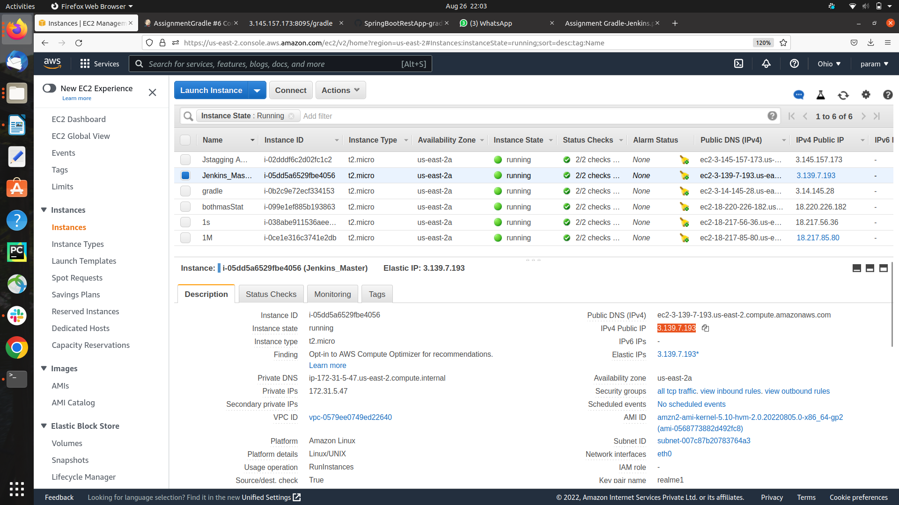

**i) One is stagging (s1) Node**

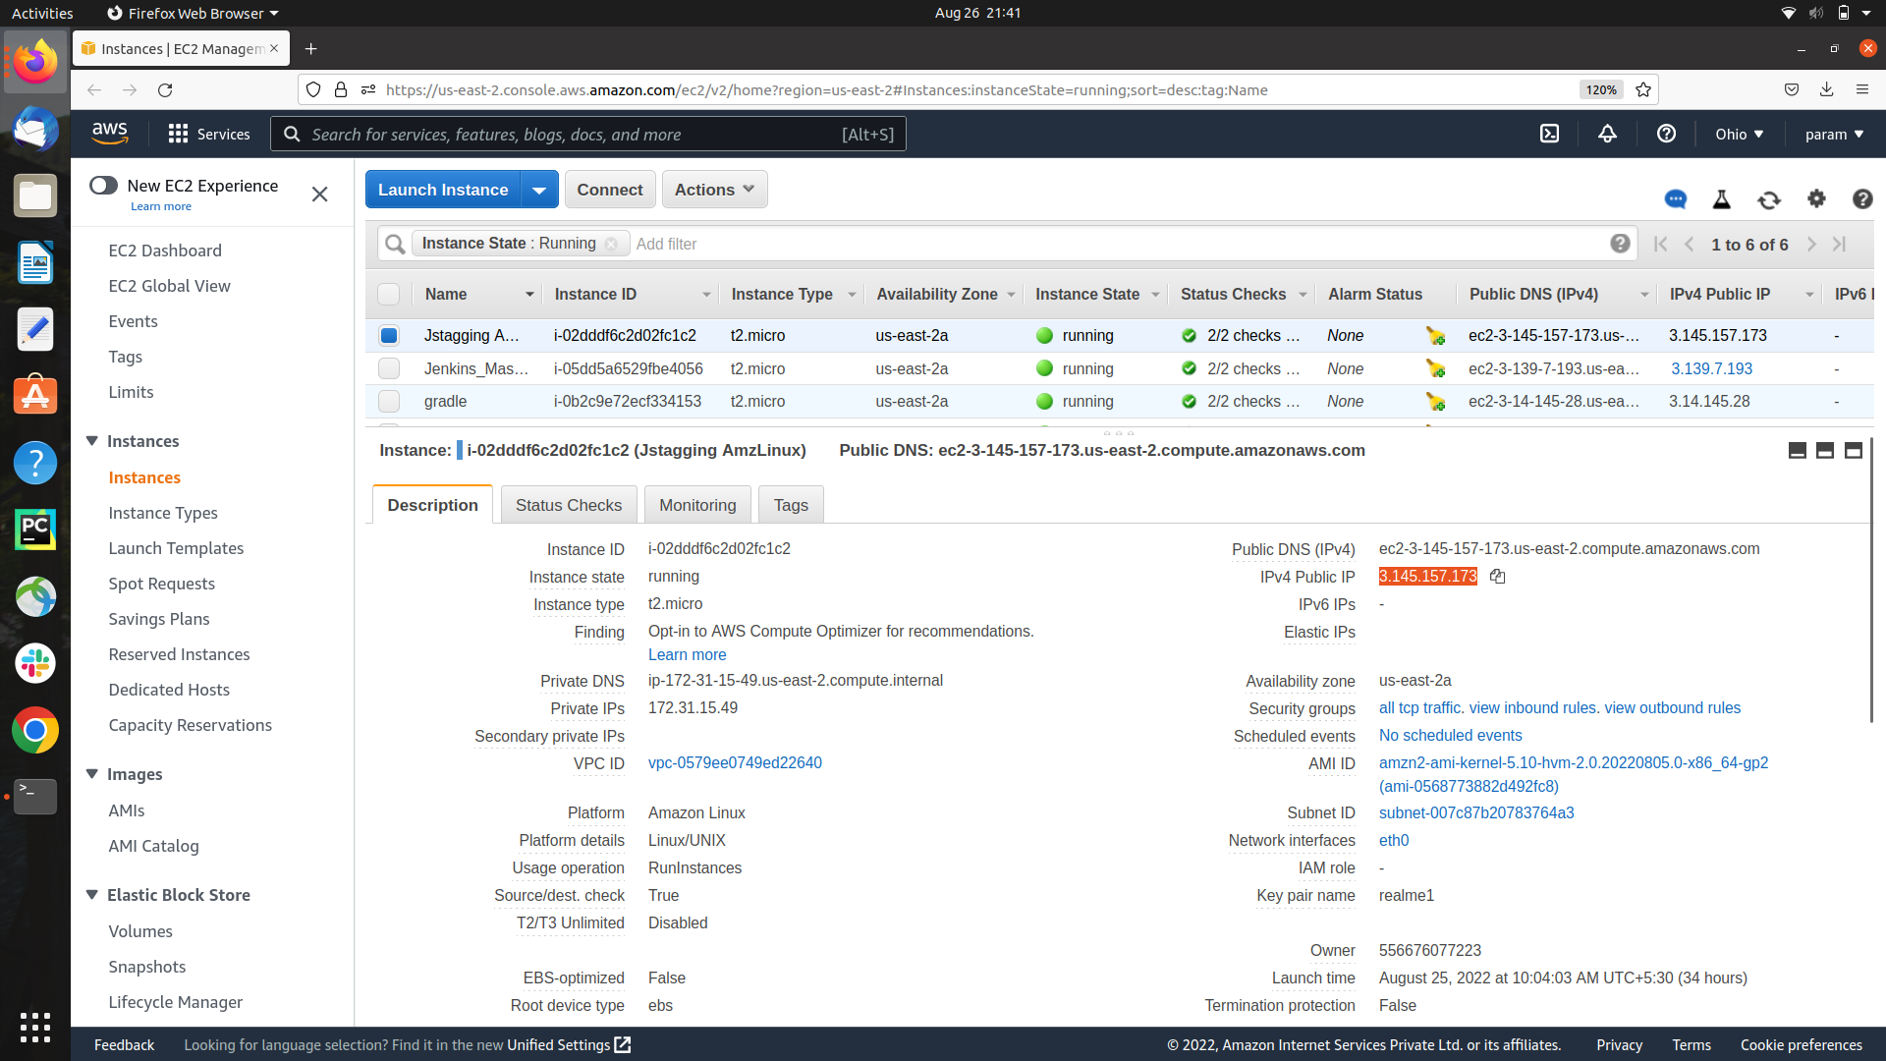

**step 2) Stagging Connected with Master Nodes**

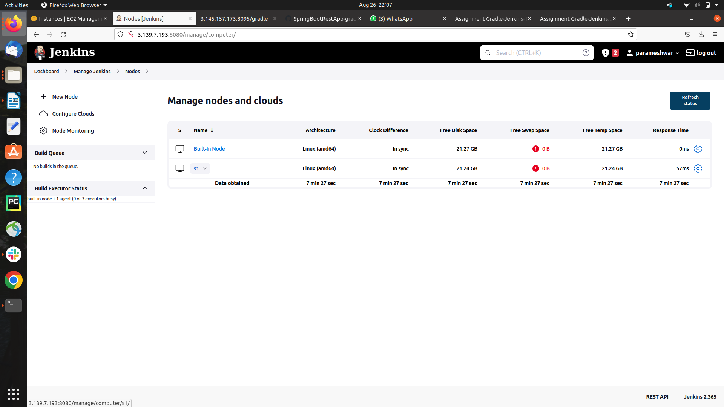

**step 4) Pushed the code to the Github repository**

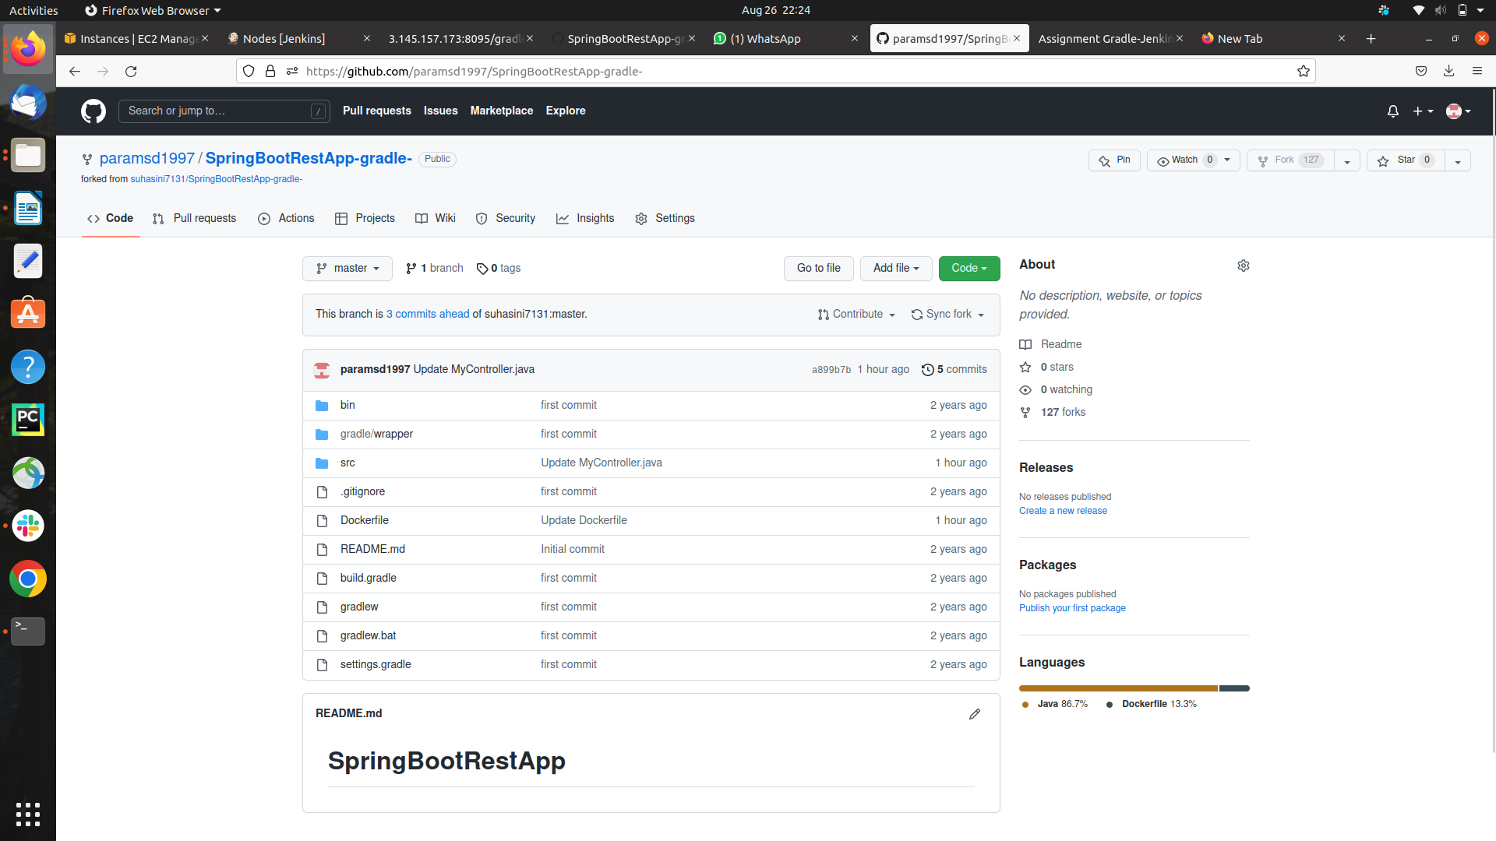

**step 4) Created the Docker file to copy the .jar file and the create Image**

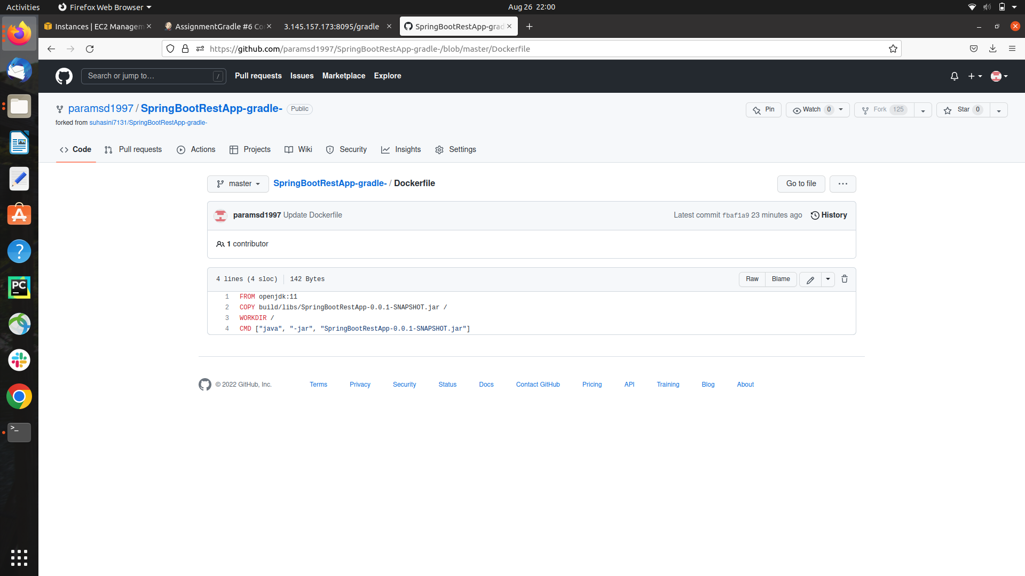

**step 5)Build a new job (AssignmentGradle)in the jenkins**

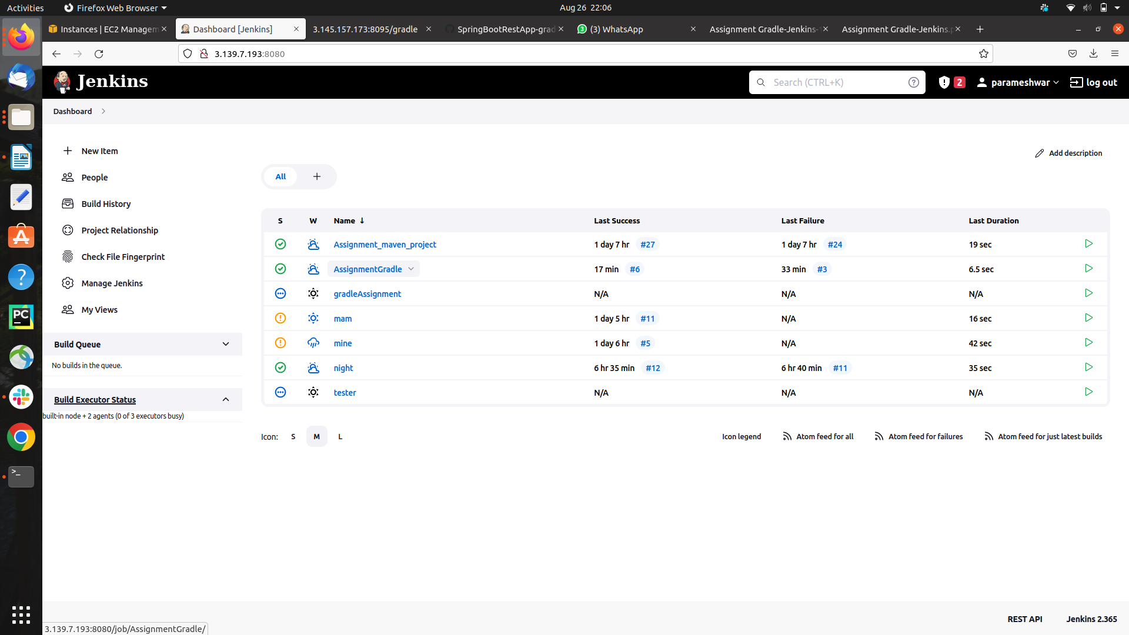

**step 6) Configurig the Project New Job**

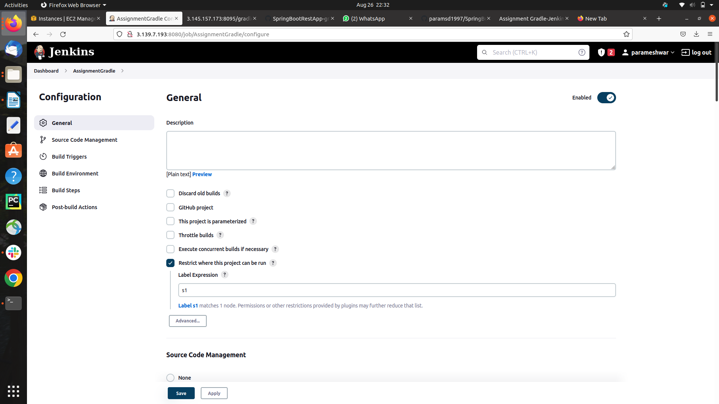

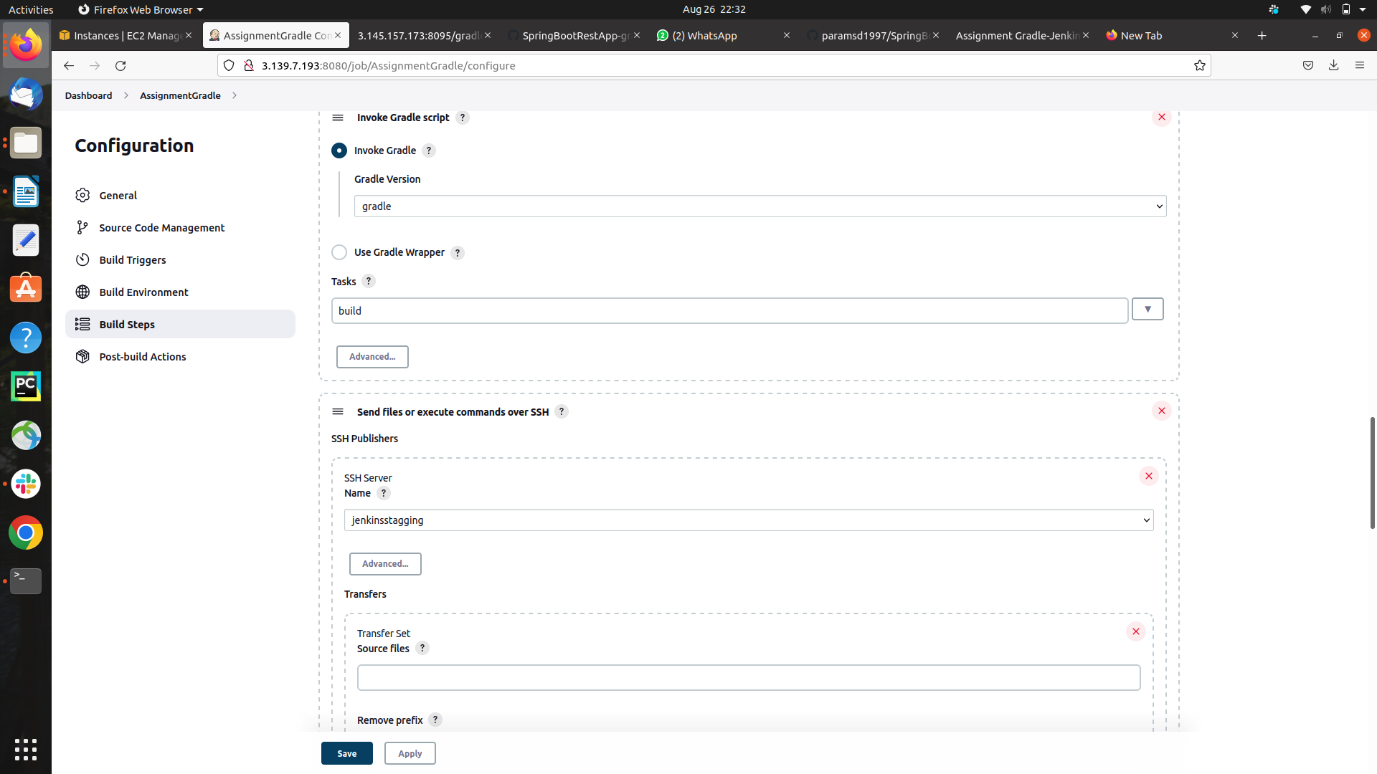**Adding the Gradle set up**

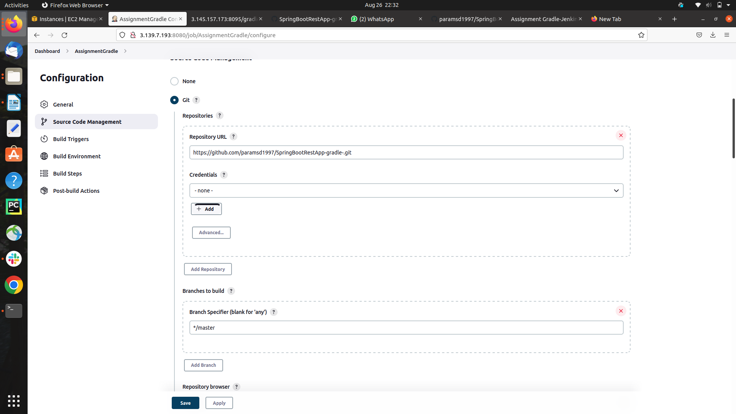

**Adding the the Git repo for Source Code Management**

**executing the Command Using SSH Server**

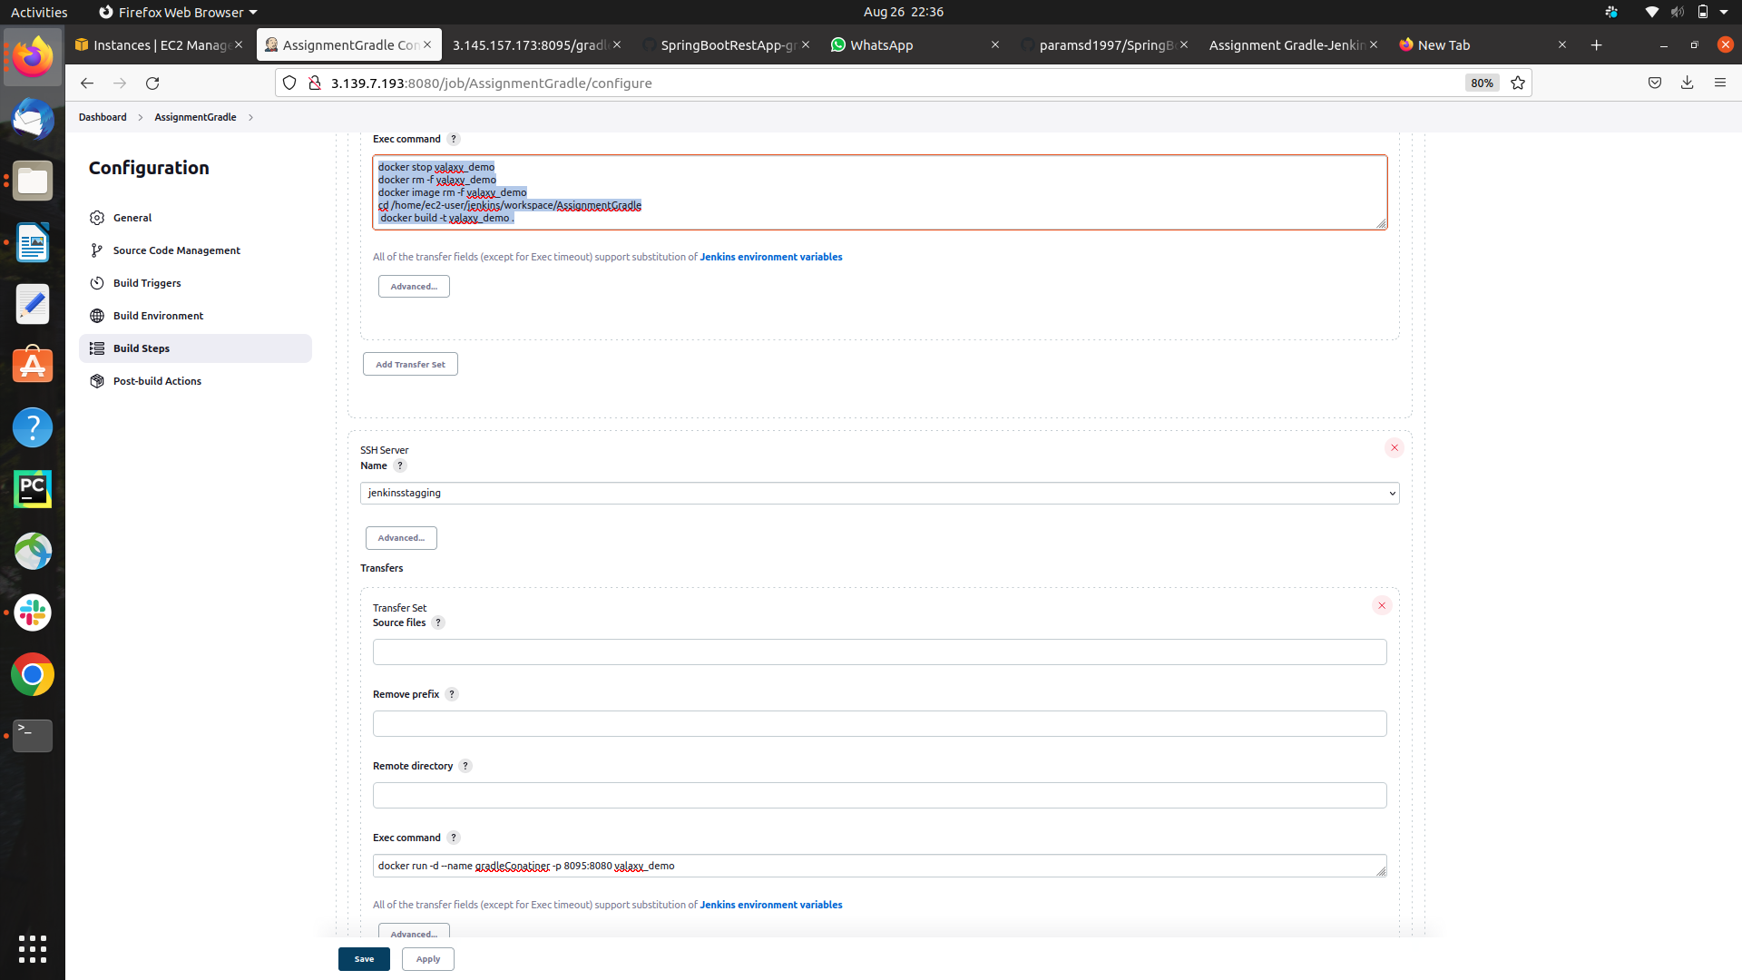

**step 7) after Builded the project Ouput got successful**

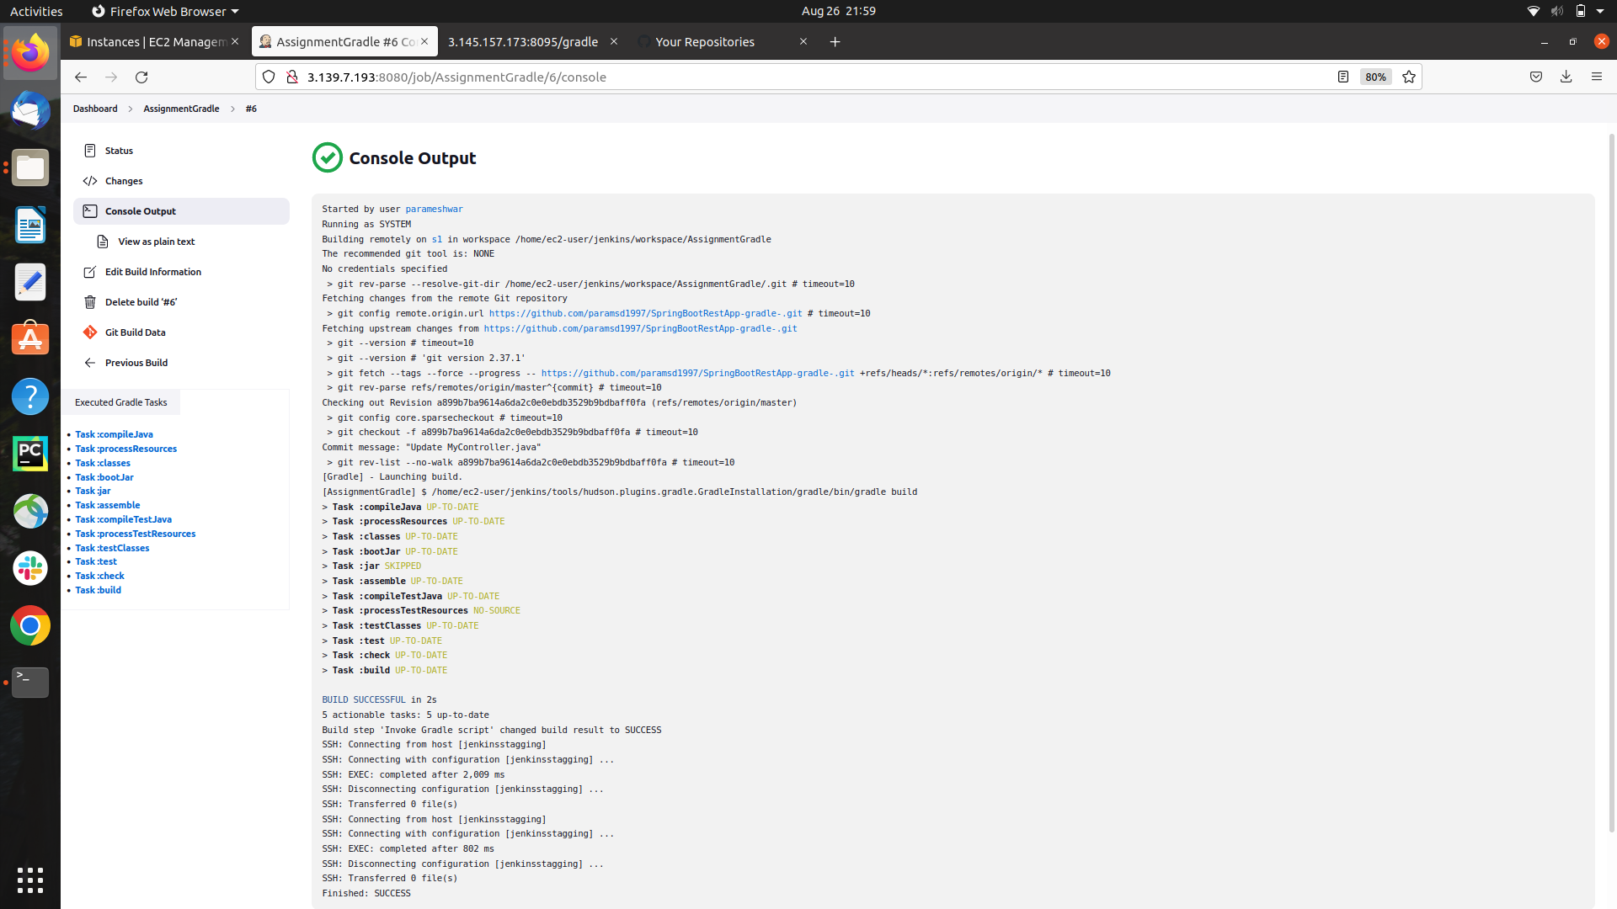

**step 8) After Building we .jar file got created into build/libs**

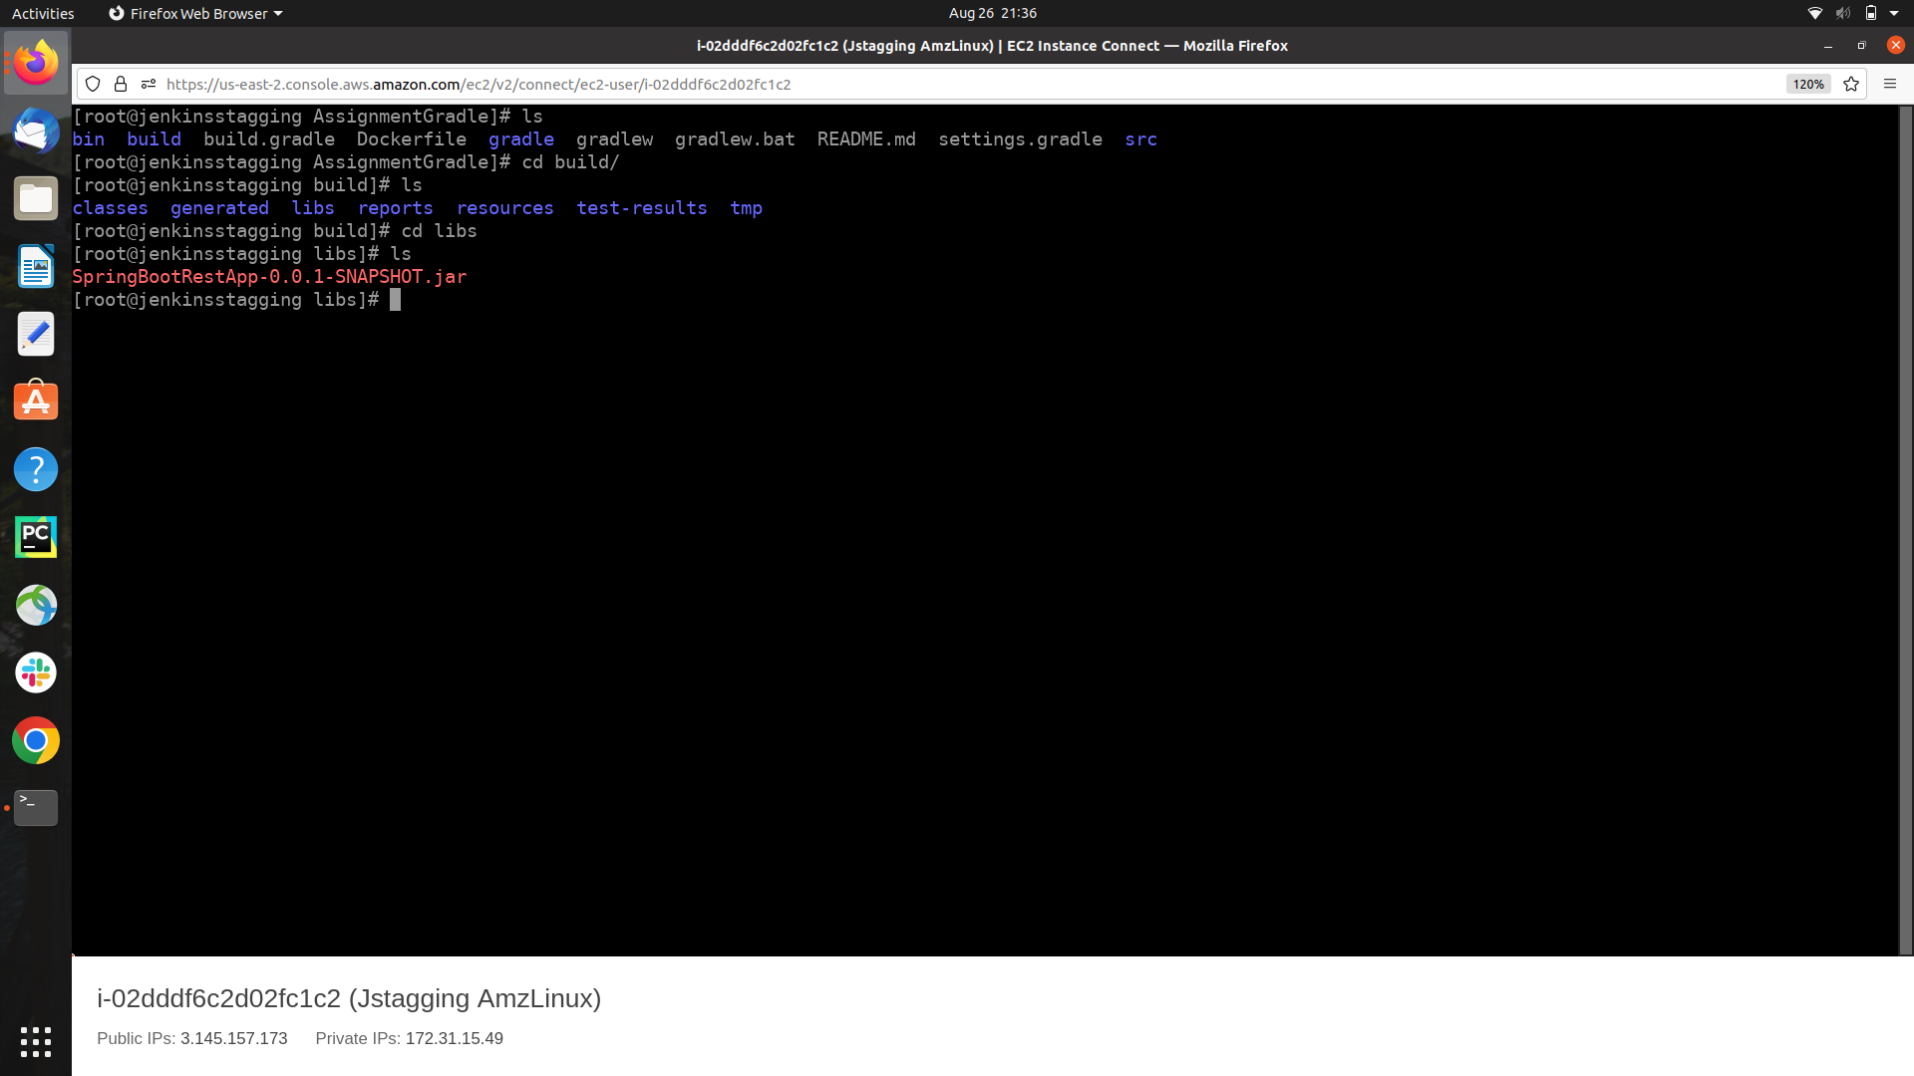

**step 9) After getting .jar file Launching the Conatiner and creating the image using Dockerfile**

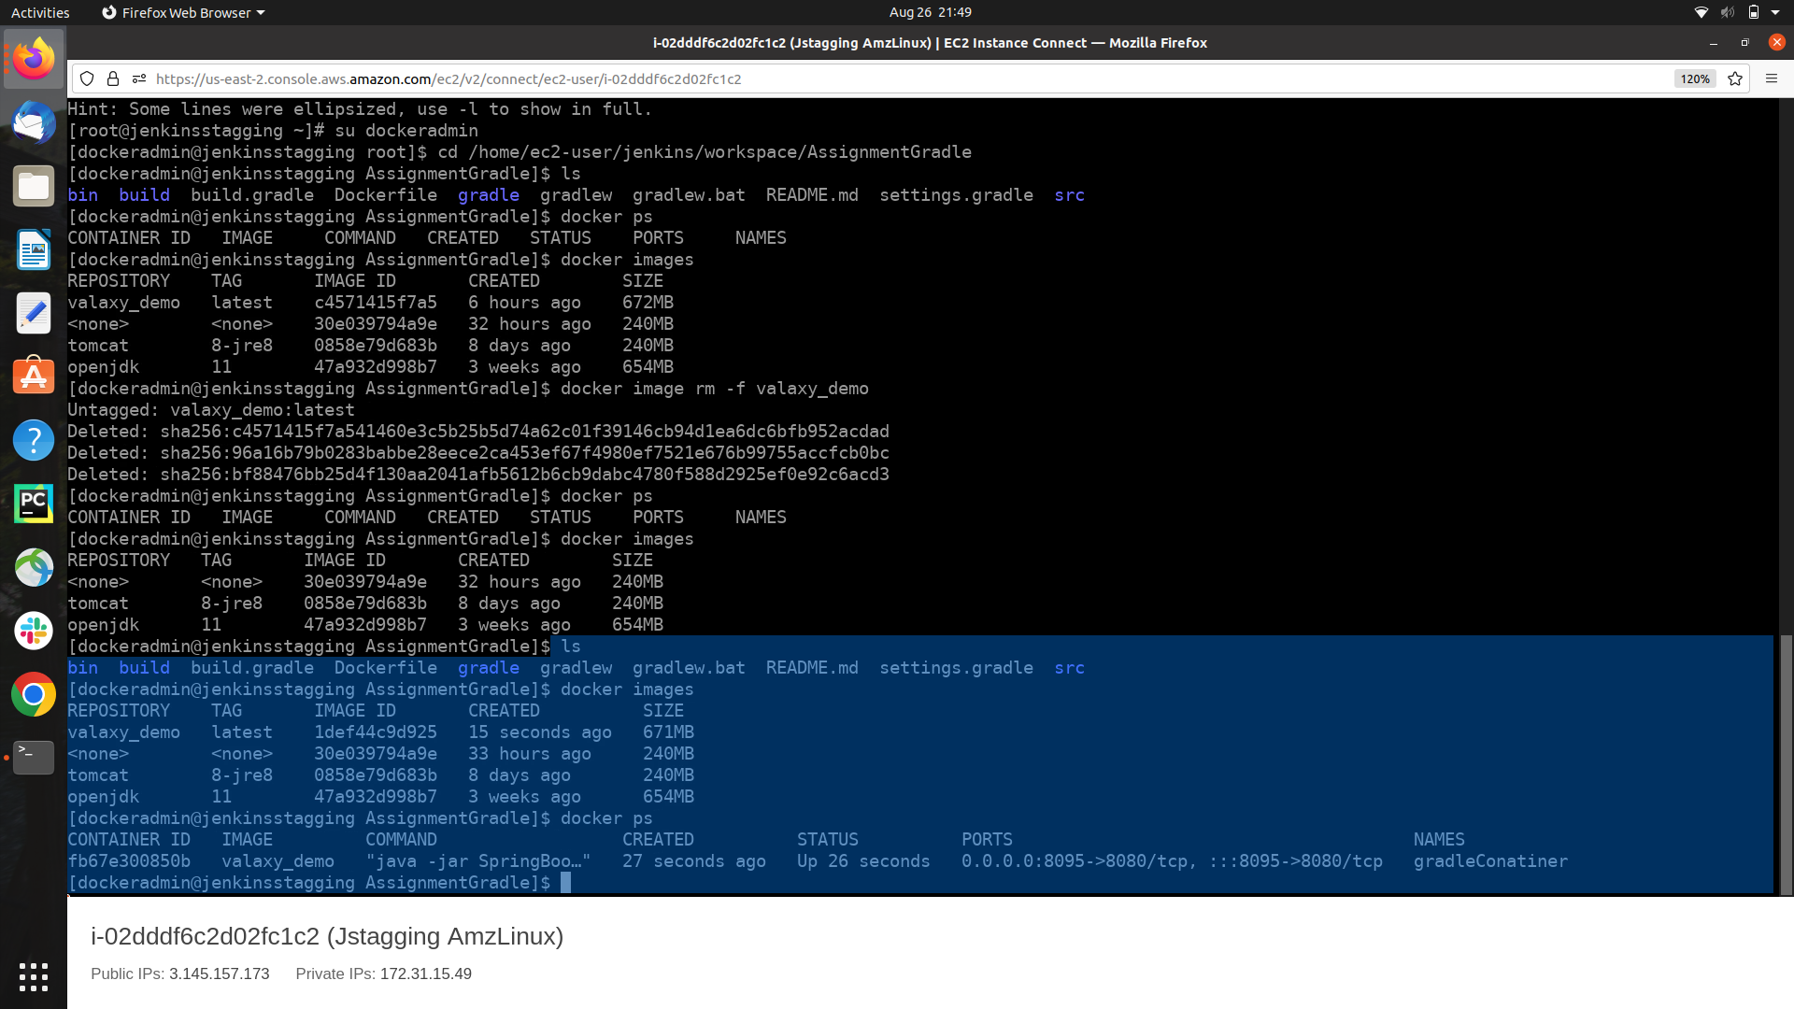

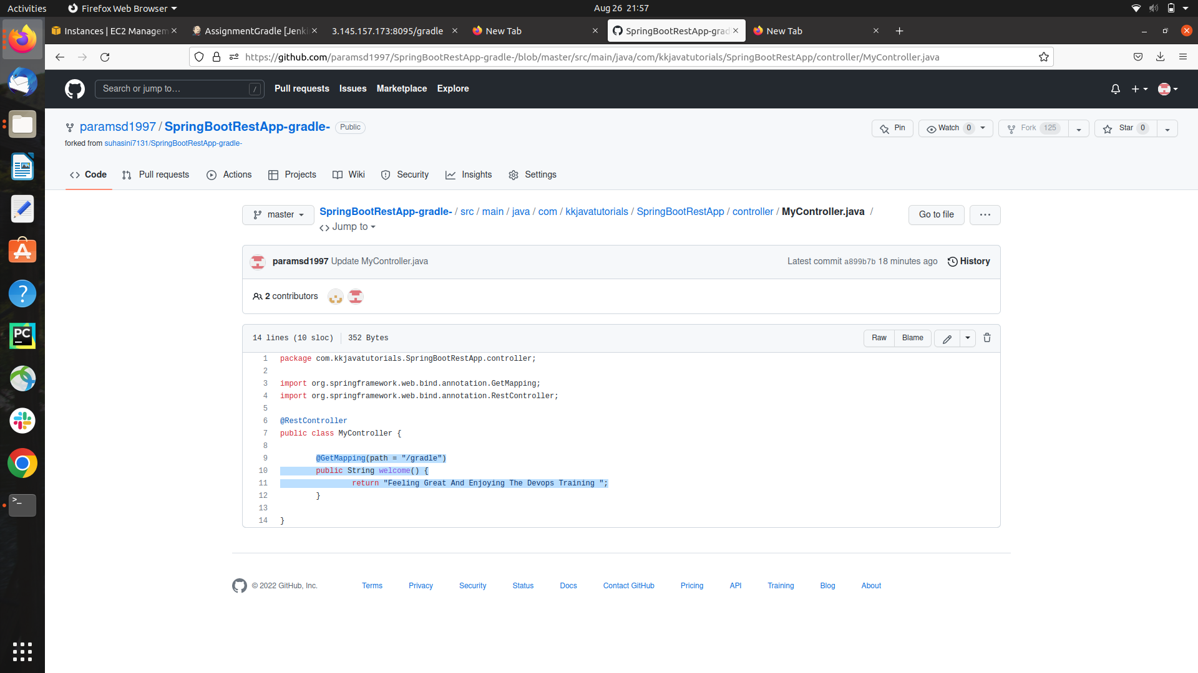**Source Code**

**step 10 ) Accessing the Server using docker container**

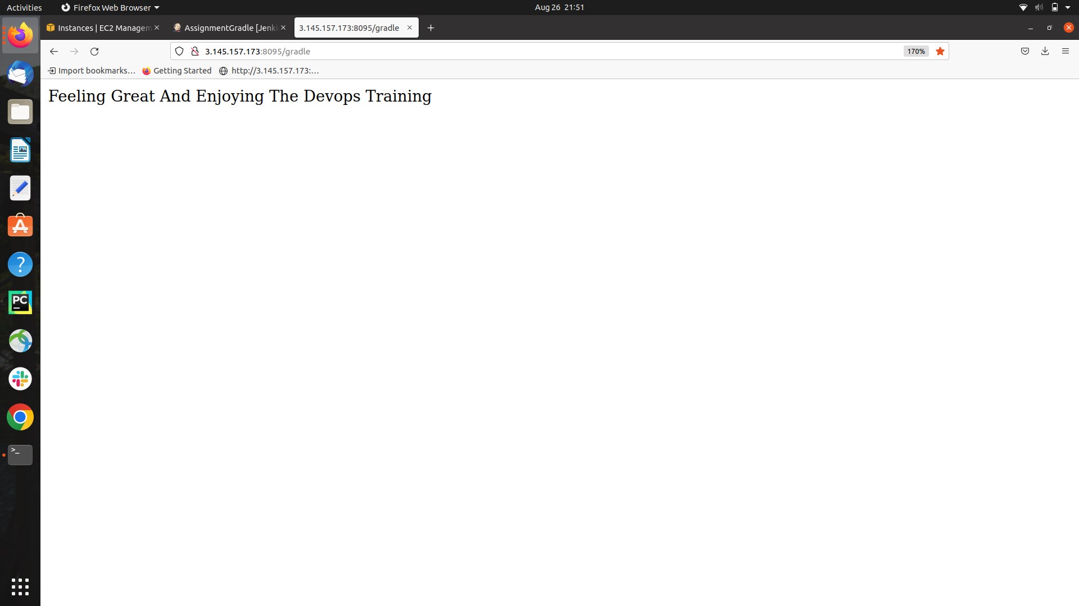

**THANK YOU !!**